## **Project “Prophecy”**

*World of Warcraft meets Path of Exile*

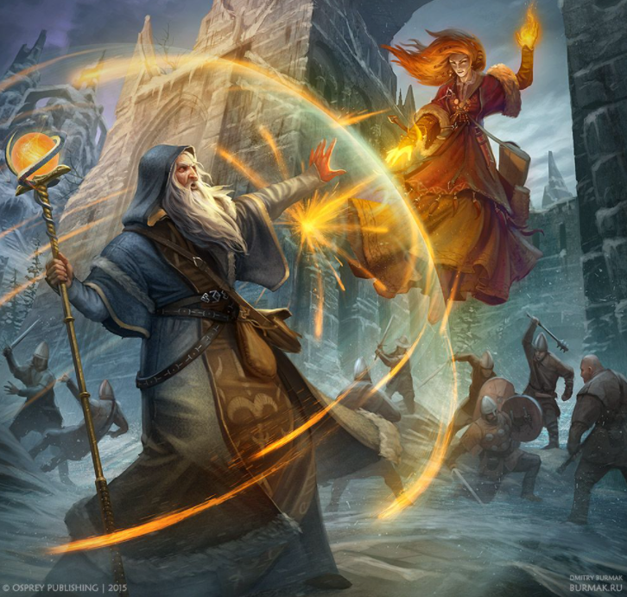

[Pinterest](https://www.pinterest.ca/pin/222576406564801885/)

**Genre:** 3d person RPG game. MMO

**Target Audience:** All audiences

**Controls:** Mouse and keyboard

**Thematic Setting:** Medieval / Fantasy / Monsters

**Tech Stack:** Unity 2019, 3D software, such as blender and maya.

**Platform(s):** Steam

**MVP Game Moment:** For now, simple clickable movement with key binds for casting abilities.

**Game Summary:**

Project “Prophecy” is a PoE stype RPG with a dark narrative. Playing as a wizard, will lead to the story of trying to save his daughter. Throughout his journey, he will encounter many obstacles along the way, such as monsters and magical beings. He will have to collect gear and learn new abilities, as he levels up to defeat more challenging foes.

**Core Player Experience:** Dark / brings the player into the story.

**Central Story Theme:**

To reach the end of the climax to save his daughter.

**Design Pillar:**

Challenging the player to complete the story and make difficult decisions.

**Remarkability:**

The narrative.

**Anticipated Steam Early Access Launch date:**

August 2021

**Feature Development Priorities:**

* Real-time combat. AOE combat skills as well.
* Stat tree with level system
* Progression bar for the story.
* Branching dialogue system
* Loot and inventory.

**Reference Games:**

World of Warcraft, Path of Exile, Diablo III, Guild Wars 2